*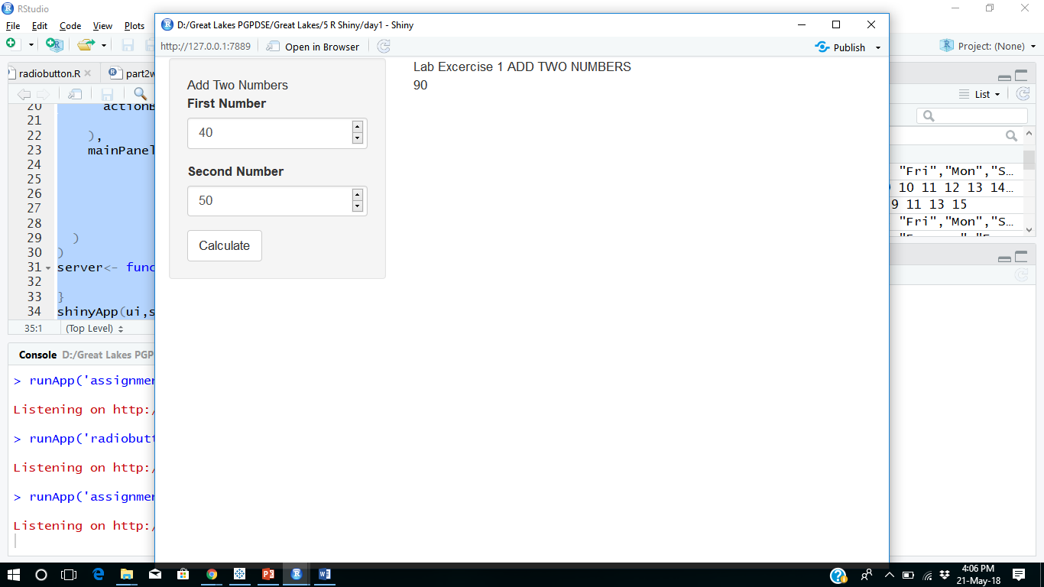*

*Addition of two number 40+50=90*

Screen shot attached below.

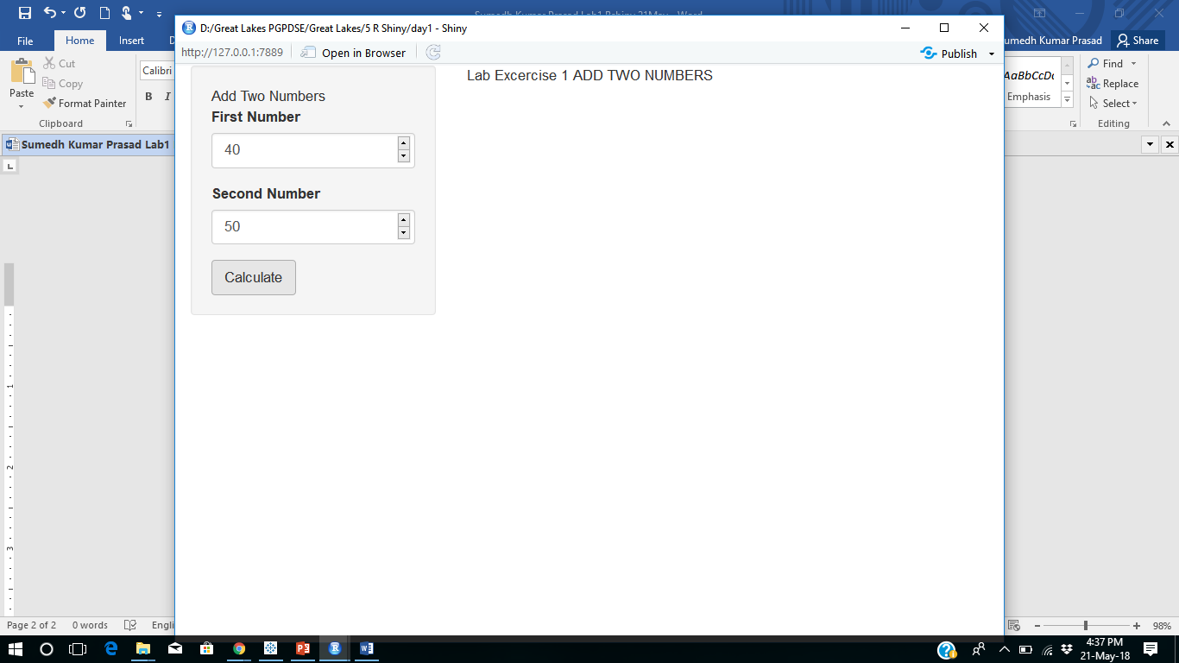

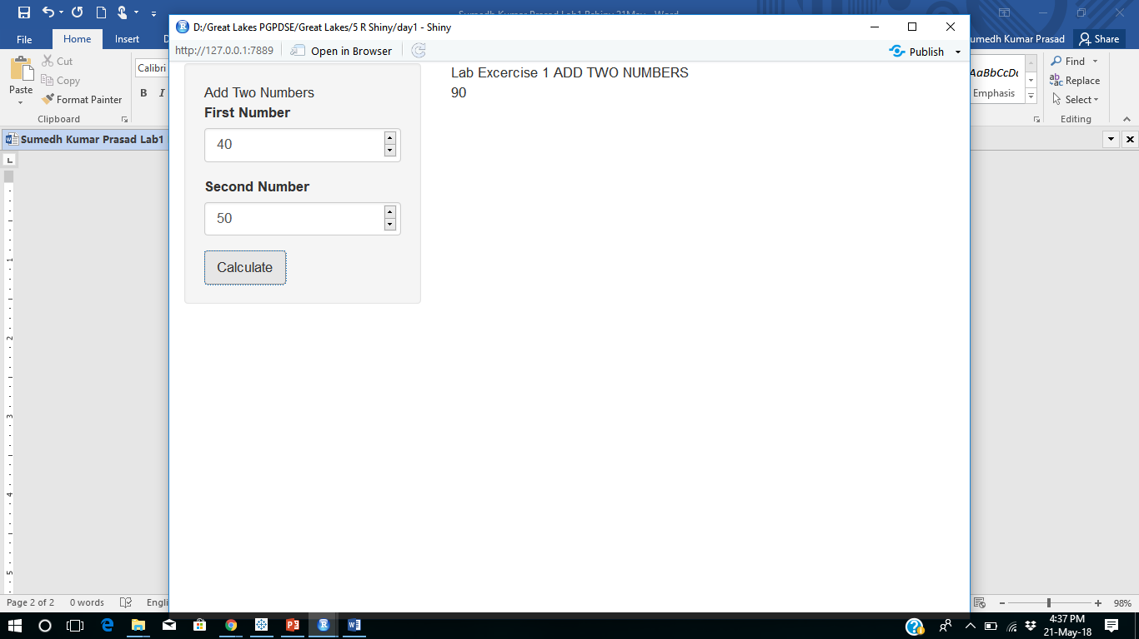

R codes below given.

R codes

library(shiny)

ui<-fluidPage(

sidebarLayout(

sidebarPanel("Add Two Numbers",

numericInput(inputId = "number1",

label = "First Number",

min = 20,

max = 100,

value = 40),

numericInput(inputId = "number2",

label = "Second Number",

min = 40,

max=100,

value = 50),

actionButton(inputId = "button",label = "Calculate")

),

mainPanel("Lab Excercise 1 ADD TWO NUMBERS",

br(),

textOutput("total"))

)

)

server<- function(input,output){

calculate=eventReactive(input$button,input$number1+input$number2)

output$total<-renderText({calculate()})

}

shinyApp(ui,server)

Second part.

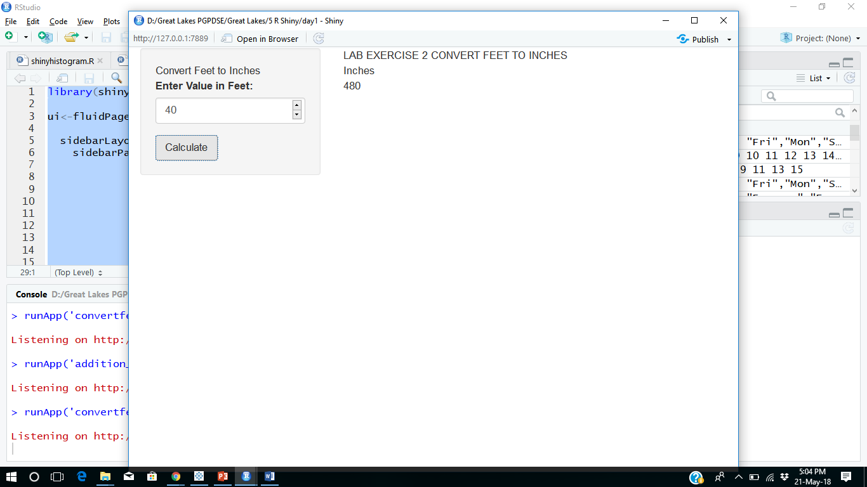

R codes

library(shiny)

ui<-fluidPage(

sidebarLayout(

sidebarPanel("Convert Feet to Inches",

numericInput(inputId = "number1",

label = "Enter Value in Feet:",

min = 20,

max = 100,

value = 40),

actionButton(inputId = "button",label = "Calculate")

),

mainPanel("LAB EXERCISE 2 CONVERT FEET TO INCHES",

br(),

"Inches",

br(),

textOutput("total"))

)

)

server<- function(input,output){

calculate=eventReactive(input$button,input$number1\*12)

output$total<-renderText({calculate()})

}

shinyApp(ui,server)